Angel Almanzar
Professor Holden-Gouveia
Linux Administration
2/1/26
Server Documentation

Prior to this assignment I had never written documentation. I saw the example video on blackboard and looked up some different ways to do it. For this documentation I have created, I wrote it the best I could with being as clear as possible.

Below are the two different distros I used for this server assignment. The first was CentOS and the second was Ubuntu. I added the links to the iso’s I chose.

Question 1:

I chose two different Linux Distros. I didn’t know what distros were until researching more about it and speaking to a tutor about the correct setup and methods. Below I write down the setup and also provide screenshots for the setup, along with showing what you can do within the virtual machines created. I tried my best to format the pictures and text together but it might be split up a little bit as there were errors with adding photos to the document and having text under the image.

Question 2:

CentOS Server Source- http://ftp.cs.stanford.edu/centos/centos/8.5.2111/isos/x86_64/

For the CentOS source it took me a while to get it to work. About two hours of trial and error. Adjusting different settings within the virtual box environment. The first issue I encountered was the discs size, the overall software space and speed of installation adjusting. I continued to work through the errors until different settings worked properly.

Below I have added some screenshots of the setup I used for CentOS, with detailed instructions on how to create the server.

Screenshot 1: (Virtual Machine Setup Below).
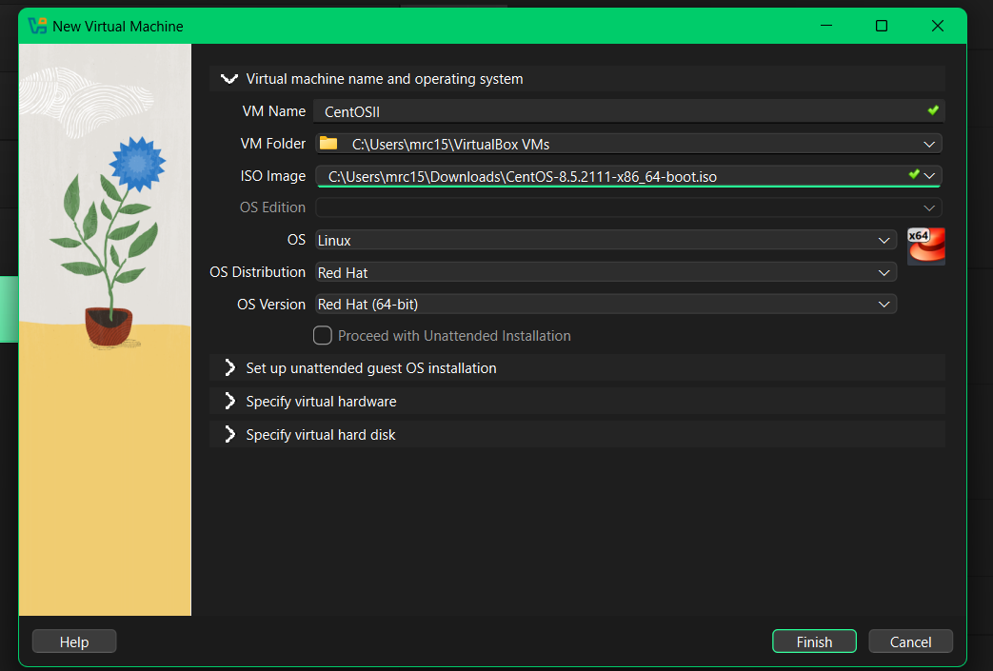
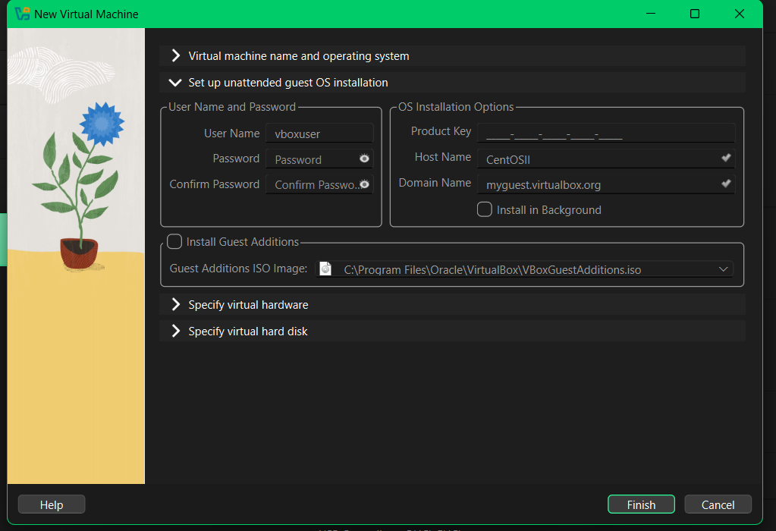
It is important to name your virtual machine, in this example the virtual machine is named “CentOSII”. Make sure to add the CentOS iso, and get it from your download folder.
The proceeding screen is the password screen. On this screen you can see the hostname which is the name of your virtual machine. In this example the virtual machine name is CentOSII, under username it is set up as vboxuser by default you can enter your name like Angel, Bobby, Jordan, etc. The password you enter can be a mix of lowercase, uppercase letters and numbers/symbols can be used.
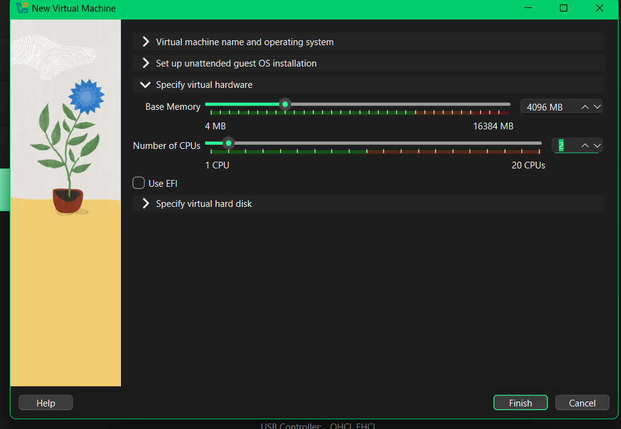
For the memory and cpu steps, it is recommended to have a base memory size doubled of that of the original, which is 2048 *2 would be 4096 for base memory. The original cpu count is 1, it is a good idea to change the number. A higher count of cpu can be better for speed and processing. For this example the cpu count is 2. It is important to have 4 processors for faster load times for the server. The default is two and makes the server run slower for different downloads, it is recommended to use double the original intended amount.

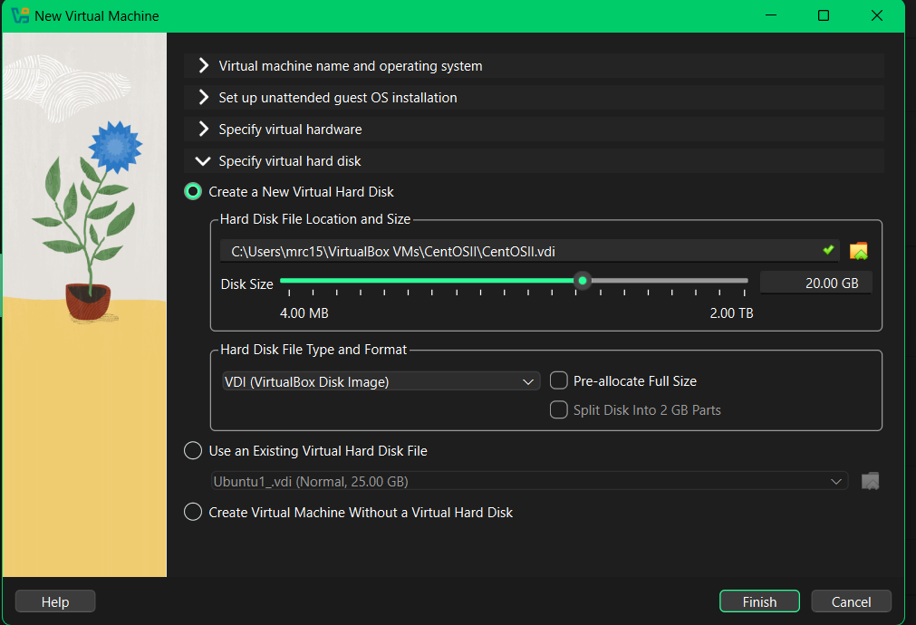
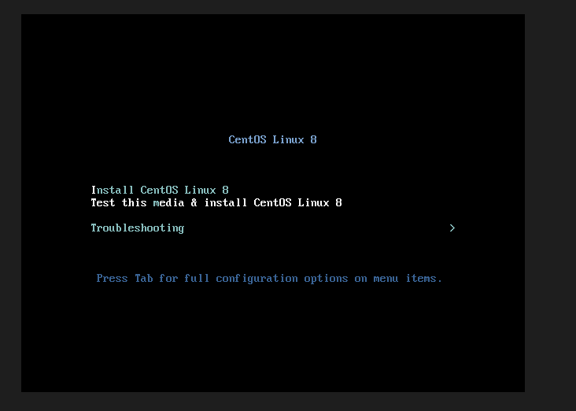
For the disc size it can stay as the default, it can be changed to either 25, 30 or 35 GB if the initial 20 is not enough capacity.
The very first screen you will see for the CentOS server is one saying CentOS Linux 8. There are a few options, the option you want to choose is “Test this media & install CentOS Linux 8.

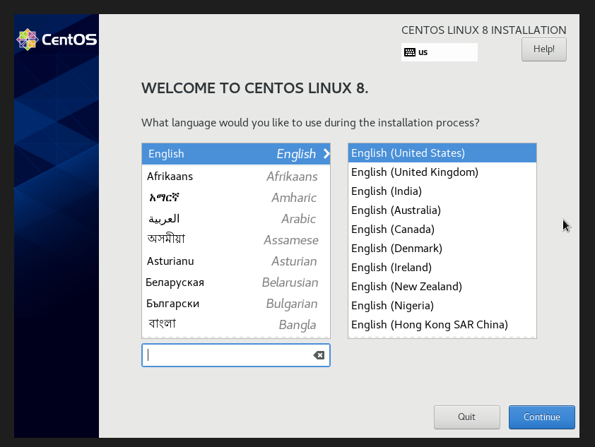

After pressing the test and install screen you will show up at this Welcome screen.You want to use your preferred language for the server, for this example I have chosen English.

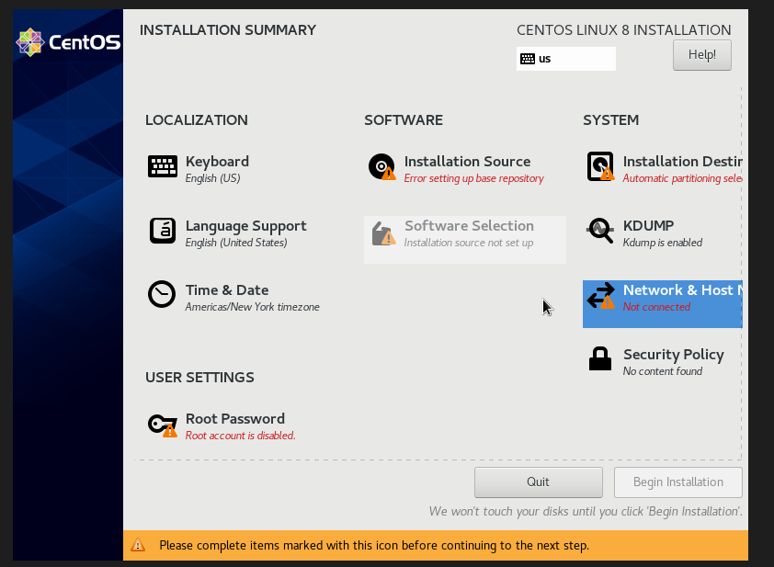
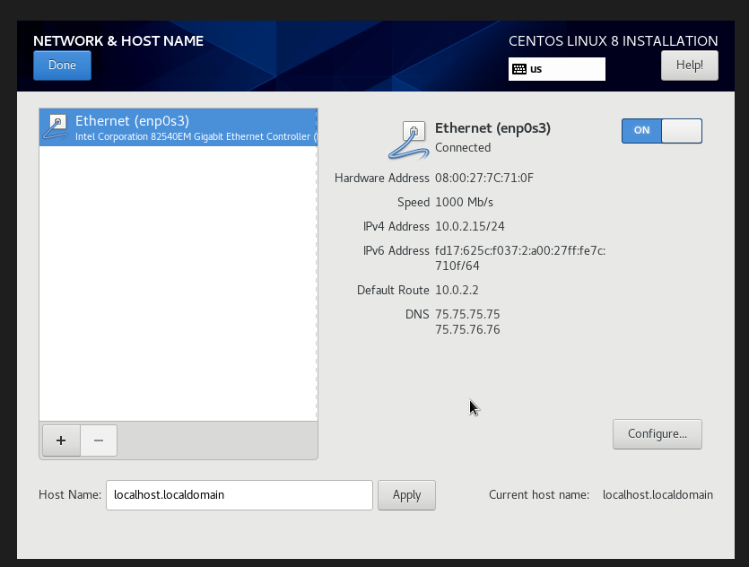
Upon choosing your preferred language you will be brought to the installation screen. This screen shows that there are errors and steps that must be taken to proceed. There are many options at this screen, you can choose any order. For this example the order I chose was “Network & Host Name”, then proceeding with the “Root Password”, “Repository Source”, and finally “Additional Software”page.
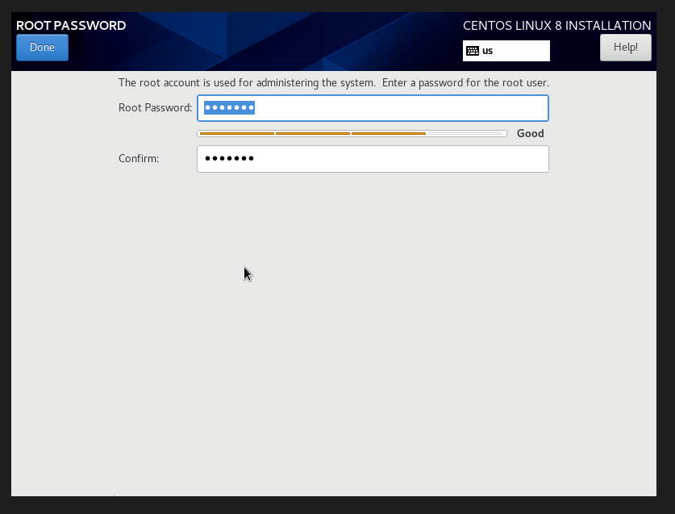
At the “Network & Host Name” screen there should be an Ethernet cable. By default this setting is disabled, you want to turn this setting on, Ethernet on to continue the installation of different services for the CentOS Server.
The next step is to set up your Root Password. This root password is linked to the user you created when creating the CentOS server within a virtual machine environment like virtualbox.
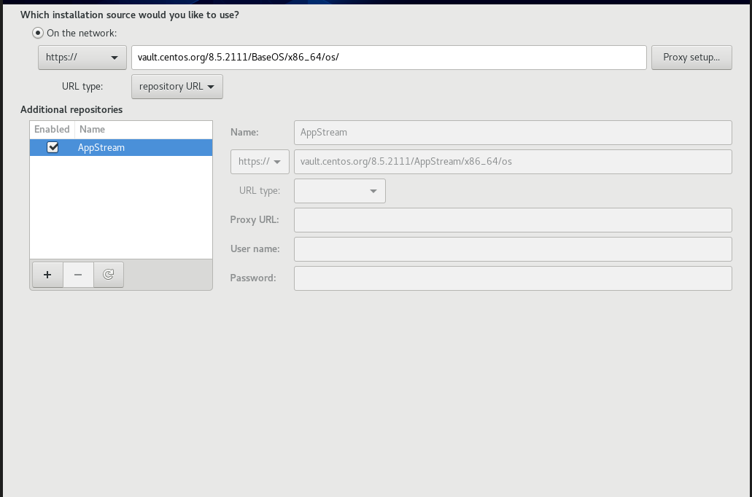
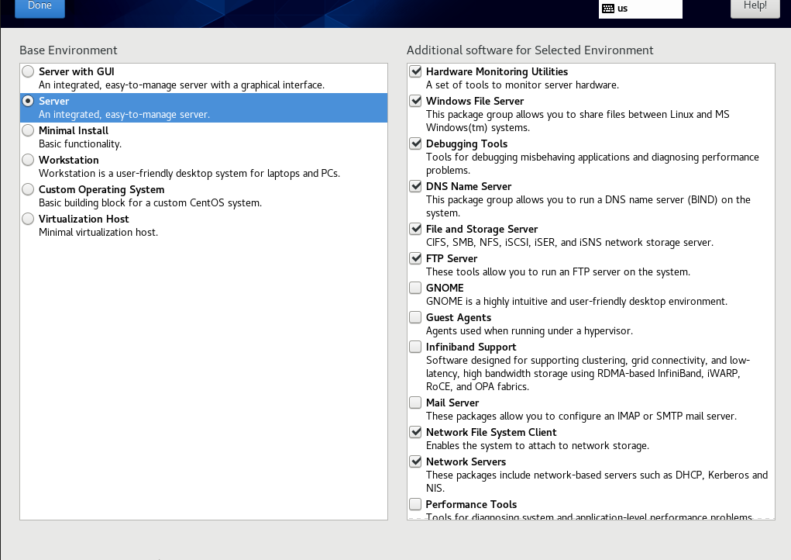
The following screenshot above for CentOS shows the system is connected to the network, the url type and what repository the virtual machine is connected to. This must be written to continue the setup.
This screenshot shows the additional software that would be used for the first distro “CentOS”. It is important to use the server as the environment, as using the server you can control different aspects of the virtual machine. The screenshot above shows the additional software that must be used for the server to run properly, they are check marked boxes in order.
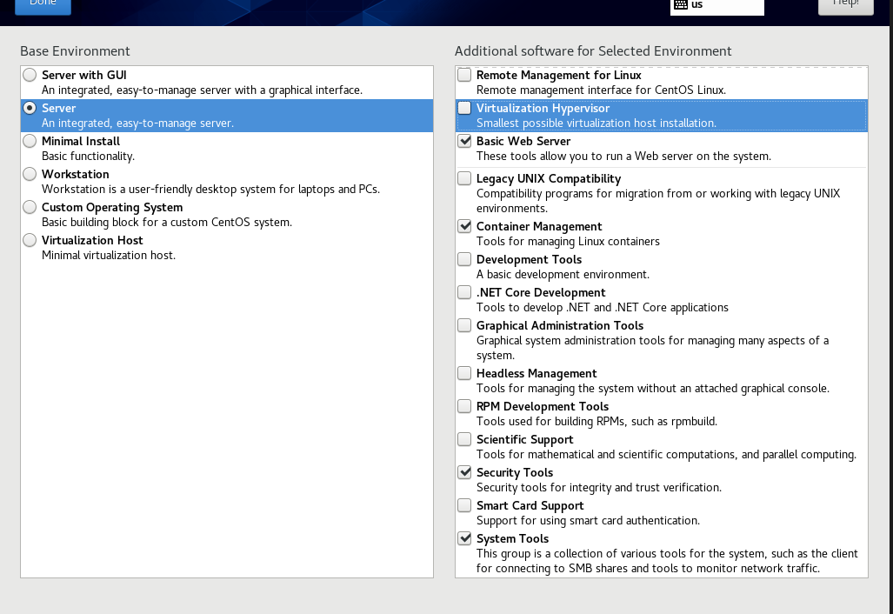
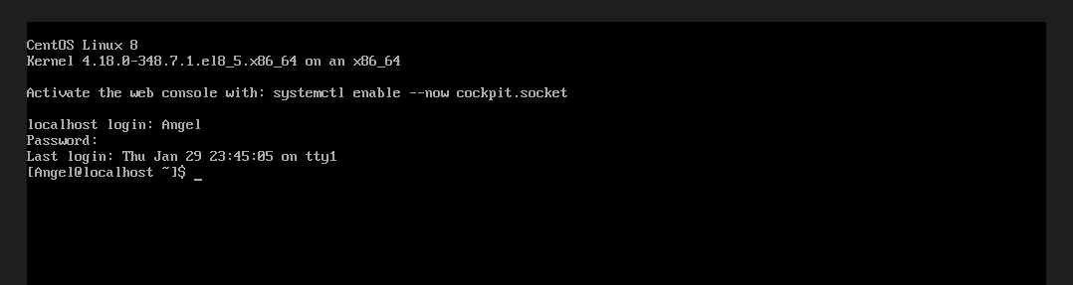
The screenshot above shows a continuation of the additional software that was used for the first distro CentOS. These continued check marked boxes are the final additions that must be added to your server, to run properly.
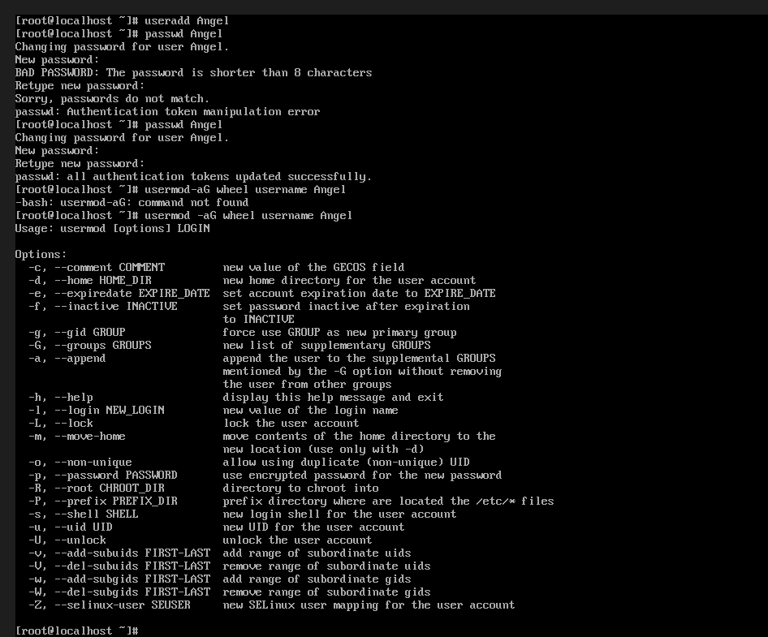
Once the server is installed, to make a new user you would write this command, ls useradd (yourname). To create a password for the user you would write this command, passwd for (yourusername). The system will then ask you to write your unique password, which must be 8 characters in length. If the password is less than 8 characters the system will give a bad password error.

Final Screenshot: (System Requirements for CentOS).

(Below).
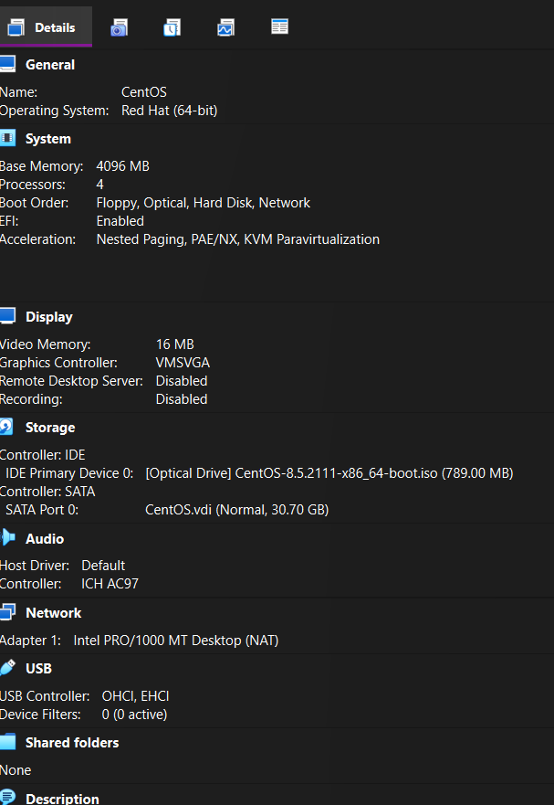

Ubuntu Server Source- https://releases.ubuntu.com/jammy/

For this source I could not find one that worked properly within the virtualbox environment. I downloaded different versions of the iso and eventually got one to work. The error I was receiving was not a large enough disc size or a disc being nonexistent.This process took me a long time to figure out and have the correct settings. I first downloaded Debian and it did not work and then I downloaded Ubuntu. Ubuntu worked properly.
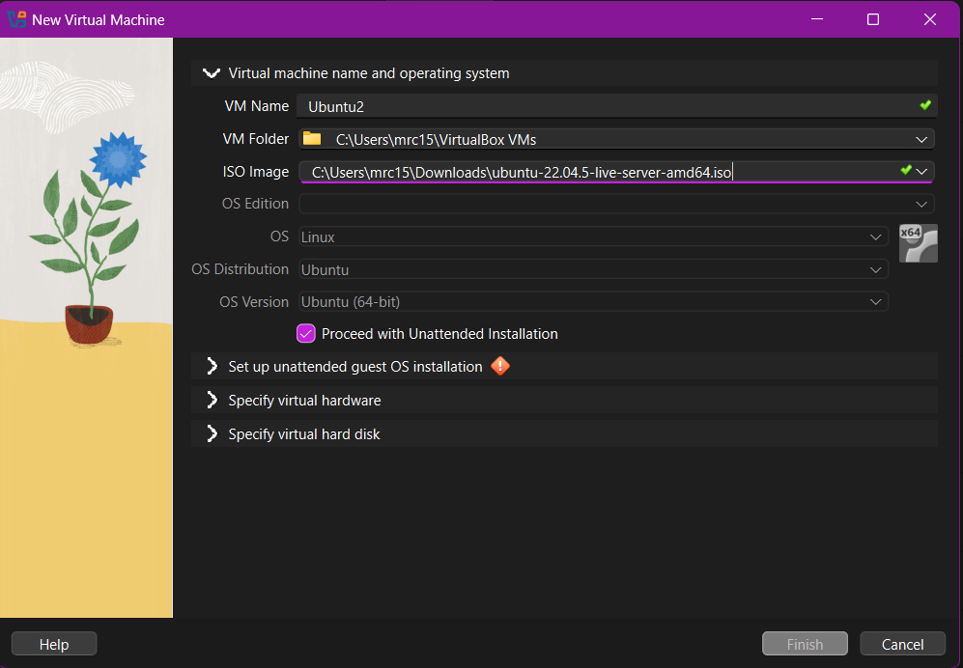
Screenshot 1:
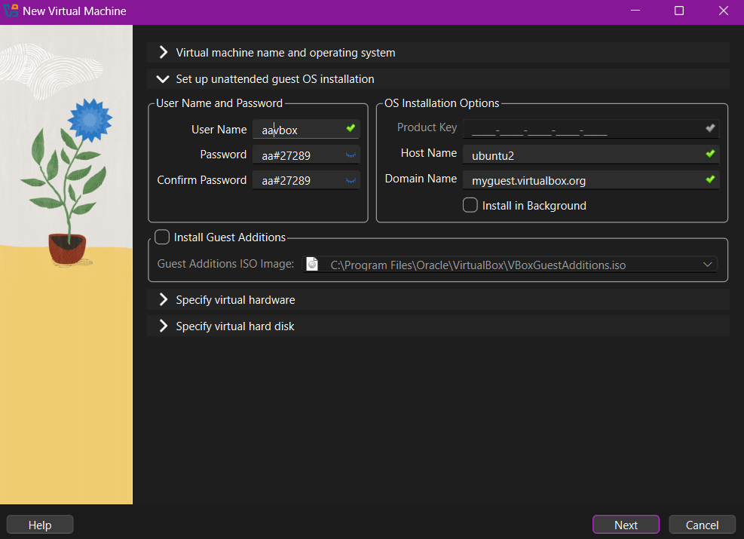
For the initial setup of the Ubuntu Server, a user should first name the server, and make sure where the download source folder is for their iso. For the virtual machine the name cannot contain any spaces or symbols, you can only add a(dash -) or numbers to the end of the name created. From download you would then click iso and click on the iso you are using like Debian, Ubuntu, CentOS etc.

For the next step the user would then create a unique username and password, confirm the domain name is accurate and the host name is set to your preferred name. For this example, my username is aavbox, my password is aa#27289. The setup requires that you have a username and password with a minimum length of 8 characters.
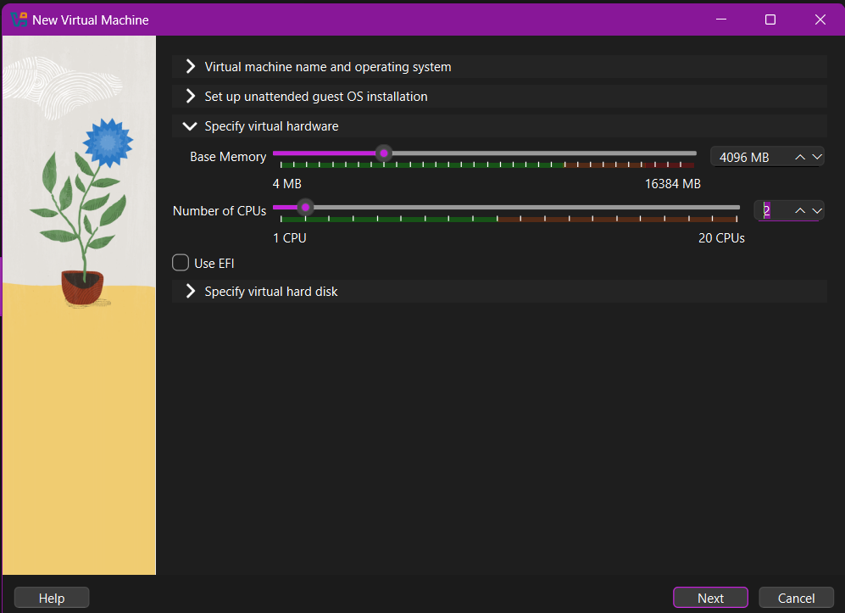
For this step it is recommended to have a base memory size doubled of that of the original, which is 2048 *2 would be 4096 for base memory. The original cpu count is 1, it is a good idea to change the number. With a higher cpu count you will get better speeds and processing. For this example the cpu count is 2. It is important to have 4 processors for faster load times for the server. The default is two and makes the server run slower for downloads, so it is recommended using double the original amount of processing power.
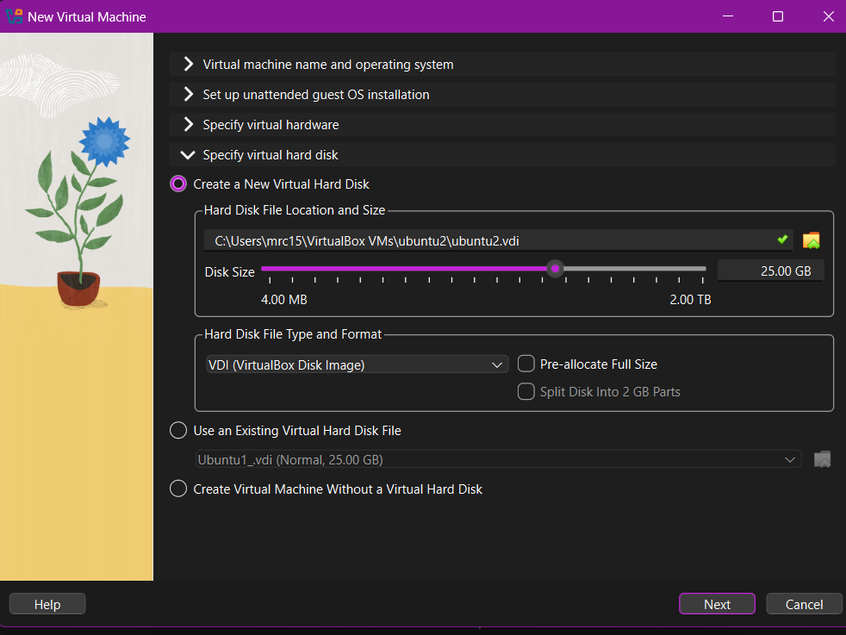

For the disc size it can stay as the default, it can be changed to either 30, 35 or 40 GB if the initial 25 is not enough capacity.

System Requirements Screenshot: (Ubuntu Server).
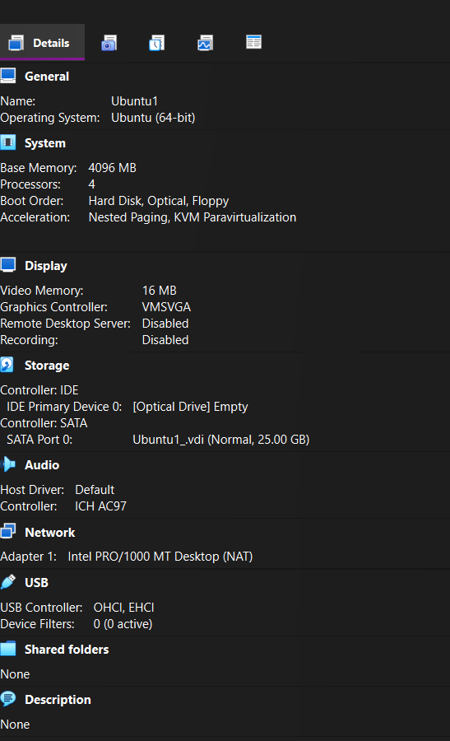
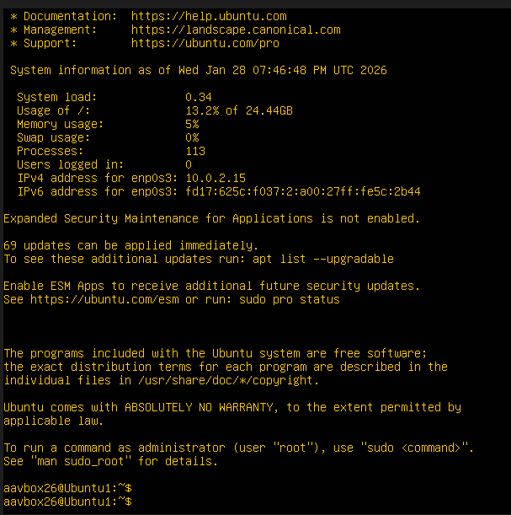

Once the server is installed the program will ask you to sign into the system with your unique specified user. The system will also ask for the password, afterwards you can start writing commands in the Linux server.

Question 3:

I used the server options for the setup of both distros. I made sure I chose the correct source. I was using the server and not the desktop operating systems version of the two linux distros, CentOS and Ubuntu.

Question 4:

I installed everything without using a GUI or minimal install. The linux servers use command prompts as intended.

Question 5:

I had made sure that both servers had internet access and tested them. Below I have added screenshots of the test for both linux virtual machines. I pinged both CentOS and Ubuntu to ping google.com.

Screenshot 1: CentOS Ping.
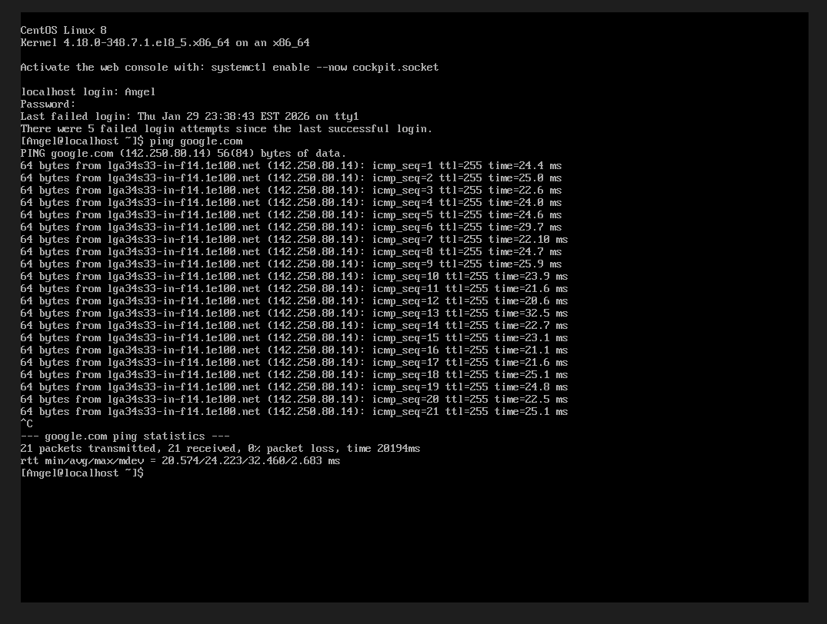

Screenshot 2: Ubuntu Ping.
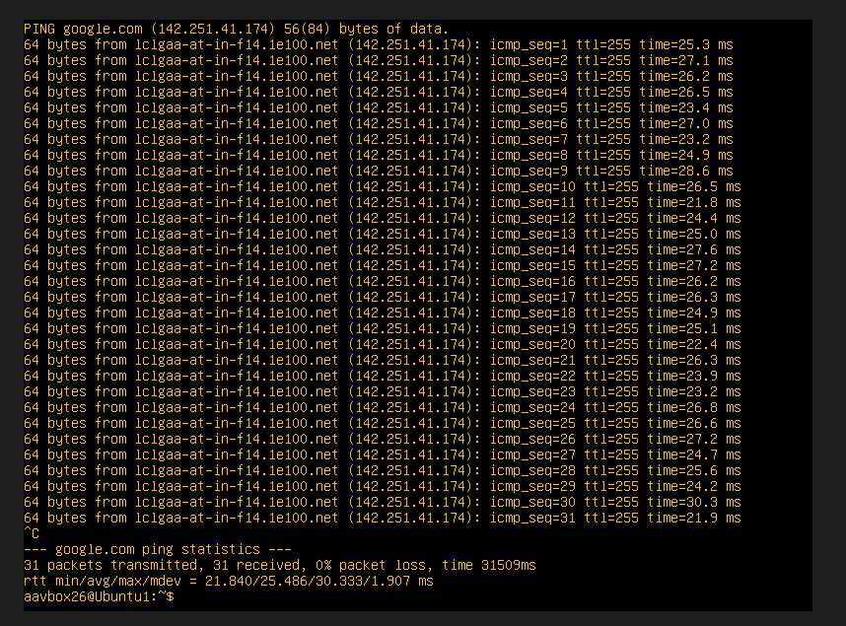

Final Question; Question #6:

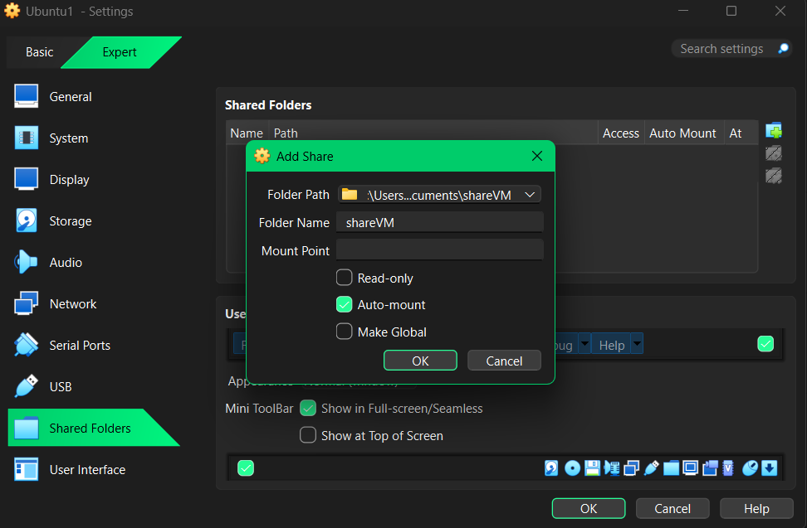
Below I have added screenshots of how to use a file share method, and how I completed the setup with step by step instructions.
The first thing I did for the file share was, create a folder on my windows PC. I named the folder shareVM, short for “Share to Virtual Machine Folder”. Then I auto-mounted the folder so it can be read in the Ubuntu and CentOS Server. You have to do this separately for both virtual servers.
When you check off Auto-mount, the system creates a permanent connection between the host computer and a directory that is located in media/sf_shareVM. This makes the file appear each time without mounting it. This only worked with Ubuntu for some reason it did not work within the CentOS environment, CentOS blocked this action.
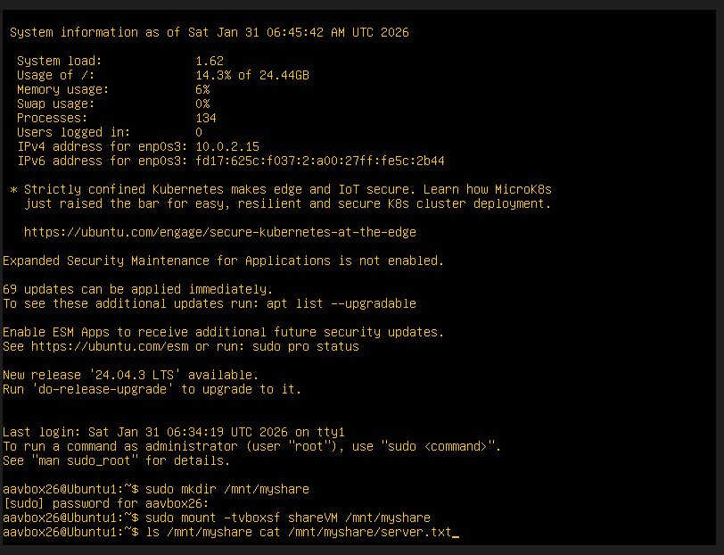
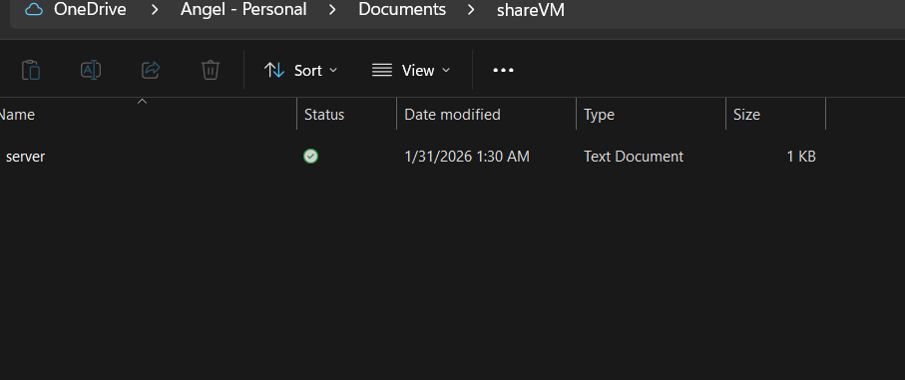
The text file within the folder named share VM was named server.txt. When writing the word and then txt the file just names it server for short and converts it to a text file for systems to read.
In the image above I use three different commands. The first command is sudo mkdir /mnt/myshare. After writing this command the system will then ask for your password for the user you created within the Ubuntu server environment. For this example, the username is aavbox26, the password contains 8 characters with a mix of letters, numbers, and symbols but cannot be seen as Ubuntu does not show anything for passwords.

The second command written in this image was sudo mount -t vboxsf shareVM / mnt/myshare. Example for commands: https://help.ubuntu.com/community/VirtualBox/SharedFolders

The final commands written in this image for file sharing was ls /mnt/myshare, then proceeding it in the same line was cat /mnt/myshare/server.txt. These three commands link the text file to the Ubuntu server.
Example for commands: https://www.virtualbox.org/manual/ch04.html#sf_mount_auto

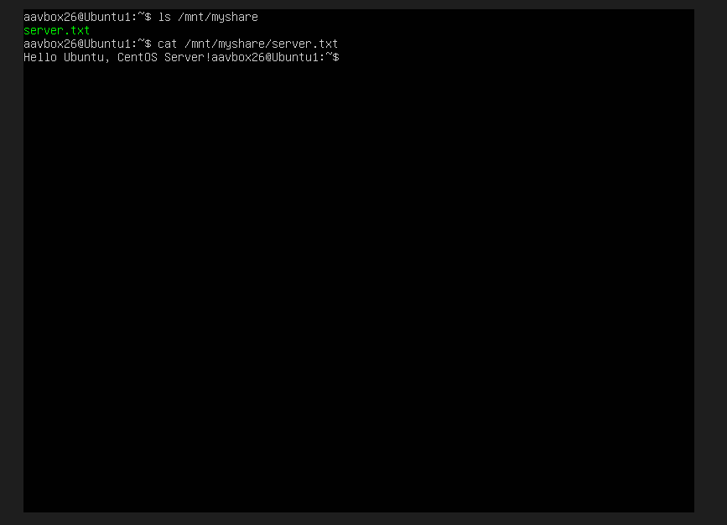

For the Ubuntu server, to see the text file that was written in the host computer environment was this command ls /mnt/myshare. The server then shows that the text file is within the Ubuntu environment.

Example for command: https://www.virtualbox.org/manual/ch04.html#sf_mount_auto

The following command shows the text written within the text file, within the Ubuntu server environment which is cat /mnt/myshare/server.txt. The Ubuntu server then reads the text, which is “Hello Ubuntu, CentOS Server!”.

Important Things to remember, Linux:

Ls- Lists. Shows all files etc.

mnt - Mount. Links to external drives or shared folders.

Myshare- Mount point, a folder created to share files.

Cat- Concatenate. A command that opens files and displays them, like “Hello Server!”.
.txt- Creating Text files.

Sudo- Runs things with administrative controls and settings.

Mkdir- Make a directory, a command to create folders.

-t - Means type. Tell Linux machines what type of file you are connecting to.

Vboxsf- An argument telling something what to do. Mounts shared folders.
https://docs.oracle.com/en/virtualization/virtualbox/6.0/user/sharedfolders.html

Media- A directory for devices, used as a mount point for storage devices.

Root- High level of authority in virtual machines. Name for an account with the highest access like a username that is an administrator for a server or virtual server environment.

The method I chose for the CentOS server shown in the screenshot below was, writing the file manually with nano within the CentOS server. The file was able to be read but it is not the original document that was also connected to CentOS. The system within CentOS continued to give errors like password invalid when trying to connect to Ubuntu or the file did not exist even though the file was also Auto-mounted to CentOS.

